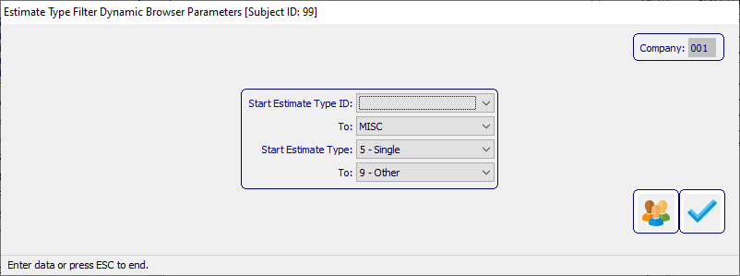

**DAOA**

By Ron Stark

Advantzware, Inc.

Dynamic Advantzware Open Analytics: Parameter Filter Developer’s Guide

Table of Contents

Dynamic Subject Parameter Filters 4

• ND3 Dynamic Parameters 5

• EstType Parameter 5

• EstTypeID Parameter 6

• Dynamic Parameter Set 7

• Estimate Type Set 7

• Estimate Type Set Details 7

o StartEstTypeID 8

o EndEstTypeID 8

o StartEstType 9

o StartEstType 9

o Set Layout 10

• ND2 Dynamic Subject 10

• Estimate Type Filter 10

• Subject Parameter Sets 11

• Parameter Set Layout 11

• Subject Table 12

• Subject Where 13

• Subject Columns 14

• Test Run 14

• Run Results 15

• EC Estimate Box Corrugated 16

• Smart Browser Definitions Section 16

• Smart Browser Main Block 16

• Procedure local-initialize 17

• Smart Browser Query 17

• EB1 Machine File 18

• Dynamic Parameter Filters assigned to selected User(s) 21

• Browser Parameter Users 21

o Users [left panel] 21

o Parameter Values [center panel] 21

o Users with Parameters [right panel] 22

Dynamic Subject Parameter Filters This guide will provide instruction on how to build a Dynamic Parameter Filter, which is then associated with a Smart Browser acting a pre-filter.

The sample below shows a Dynamic Parameter Filter attached to EC Corrugated Box Estimate, which is outside the NoSweat Framework and requires manual coding, outlined below in this document.

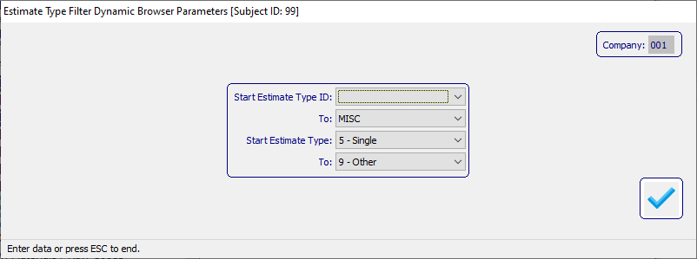

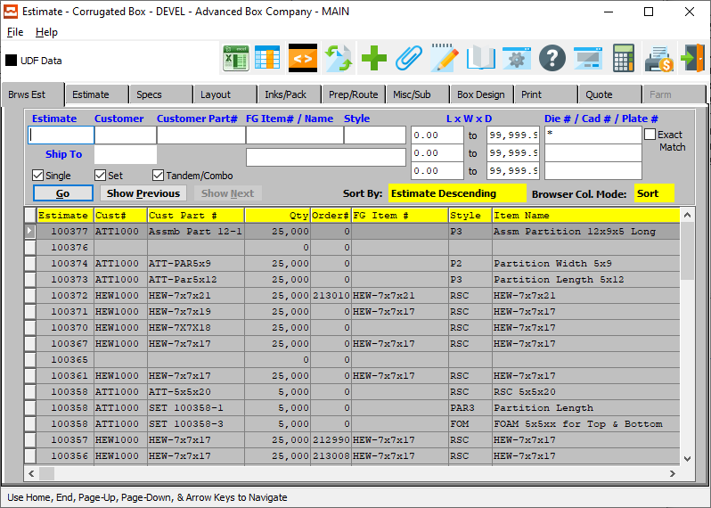

Reference Dynamic AOA Subject & Parameter Users Guide on how to construct a Dynamic Parameter Set and Dynamic Subject.

* ND3 Dynamic Parameters create the following dynamic parameters using ND3 Dynamic Parameter Builder, [Parameters] Tab.
* 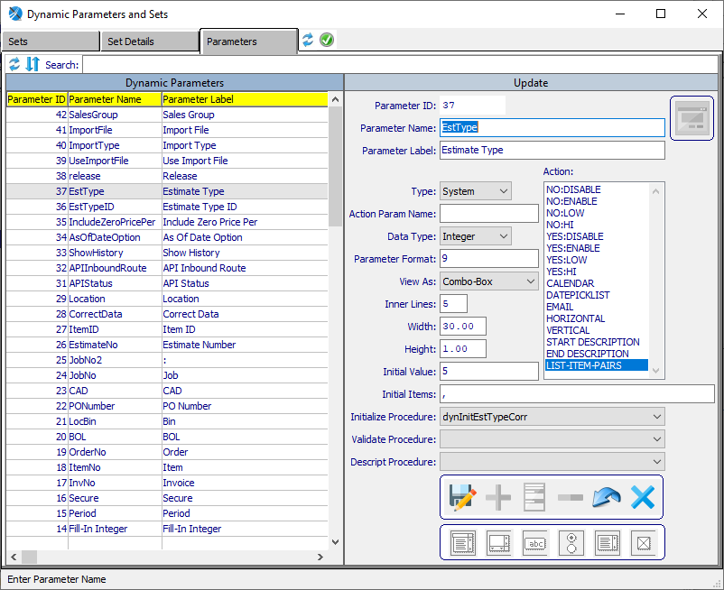
* EstType Parameter – Estimate Type, which is a Combo-Box listing estimate types 5 through 9. The Super Procedure AOA/spDynInitializeProc.p (procedure dynInitEstTypeCorr) is executed to load valid values.
* 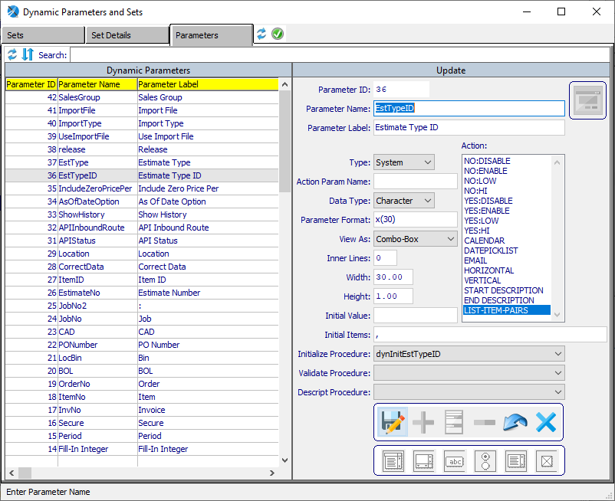
* EstTypeID Parameter – Estimate Type ID, which is a Combo-Box listing estimate type IDs Blank and MISC. The Super Procedure AOA/spDynInitializeProc.p (procedure dynInitEstTypeID) is executed to load valid values.
* Dynamic Parameter Set create the following dynamic parameters using ND2 Dynamic Parameter Builder, [Sets] Tab.
* 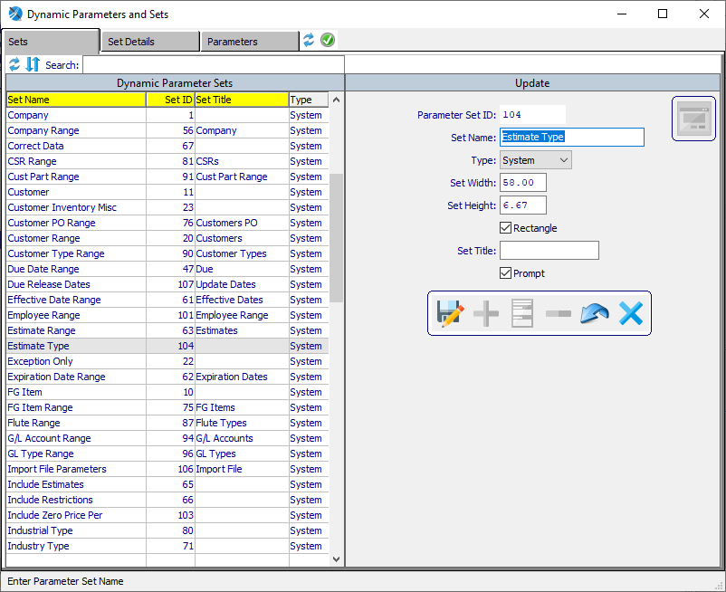
* Estimate Type Set – is the set header which will contain Dynamic Parameters.
* Estimate Type Set Details – is made up of 4 Dynamic Parameters, StartEstTypeID, EndEstTypeID, StartEstTypeCorr and EndEstTypeCorr.
  + 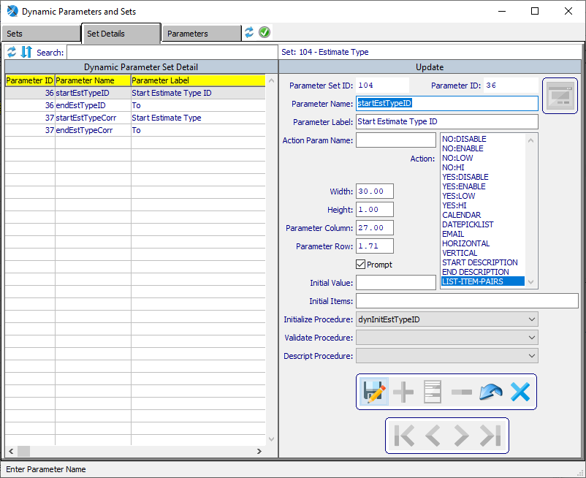
  + StartEstTypeID
  + 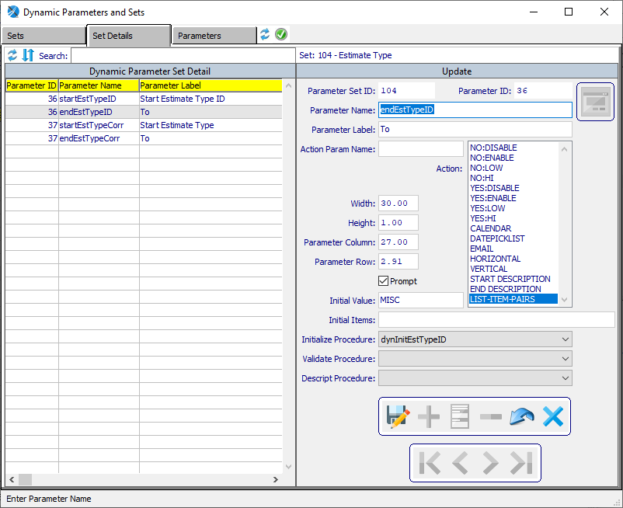
  + EndEstTypeID
  + 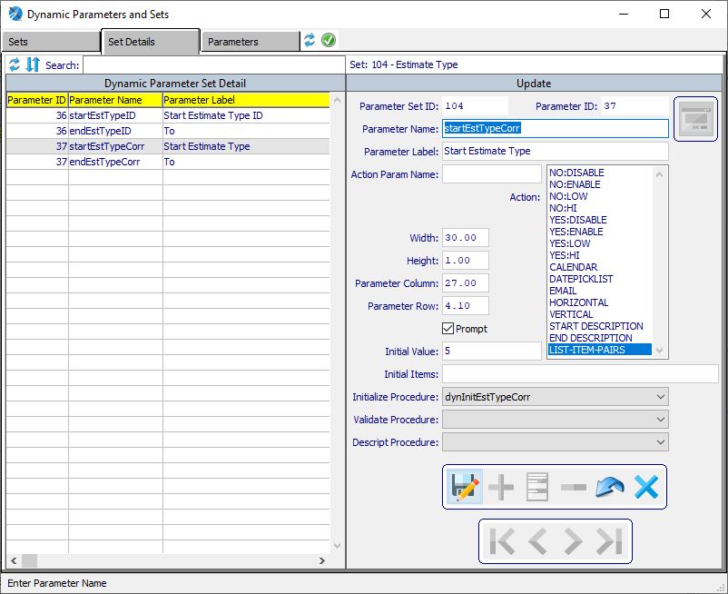
  + StartEstType
  + 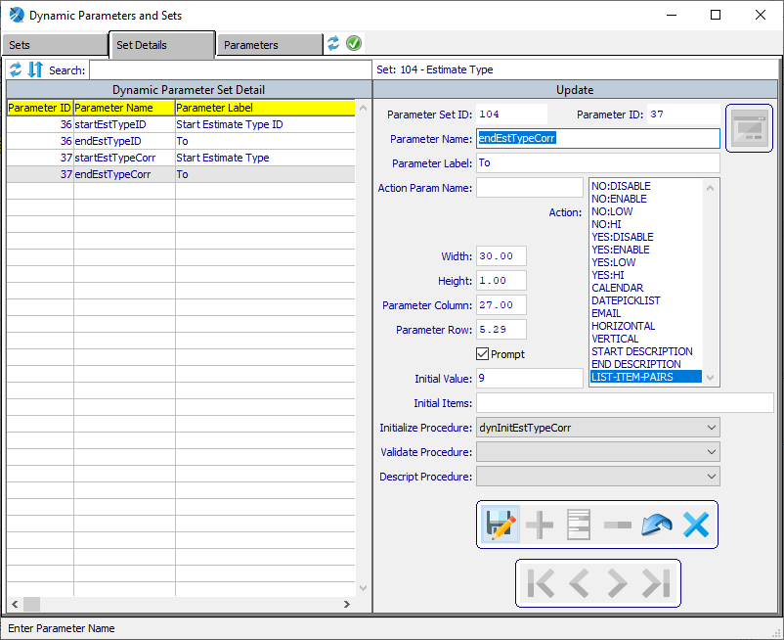
  + StartEstType
  + 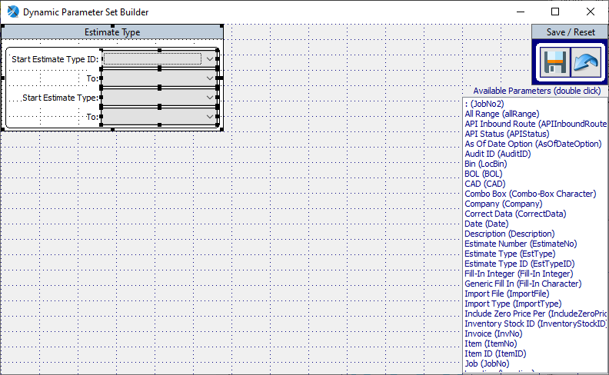
  + Set Layout
* ND2 Dynamic Subject create the following dynamic subject using ND2 Dynamic Subject Builder, [Parameters] Tab.
* 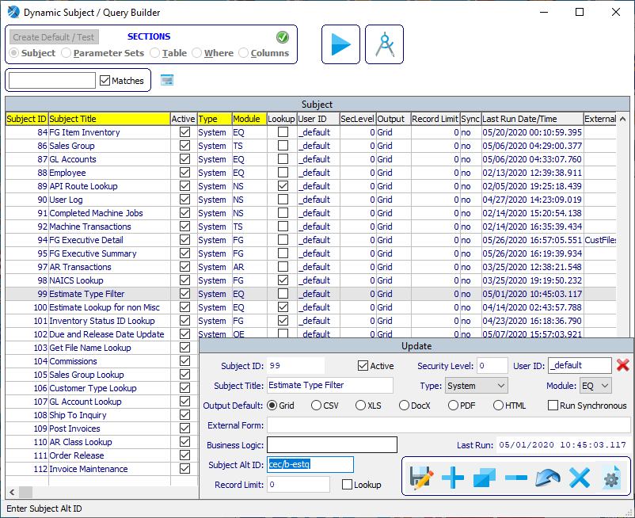
* Estimate Type Filter – Dynamic Subject, is set apart from other subjects when a value is placed in Subject Alt ID. This alternate identifier is how a Dynamic Parameter Filter is linked to the associated Smart Browser. For this example the value is set to “cec/b-estq”. This value was selected because the Smart Browser is “cec/b-estq.w”, but not this value can be any free form value as long as it is unique within the set of Dynamic Subjects. How this is accomplished is detailed later in this document.
* 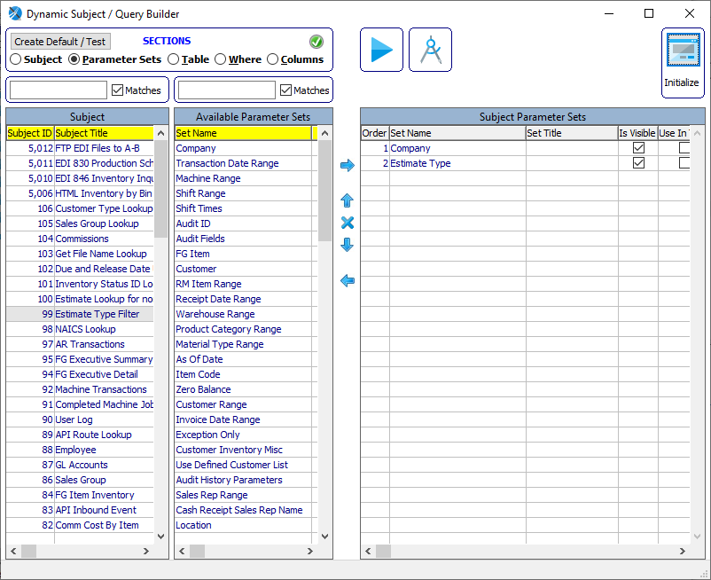
* Subject Parameter Sets – here the Parameter Sets Company and Estimate Type are selected.
* 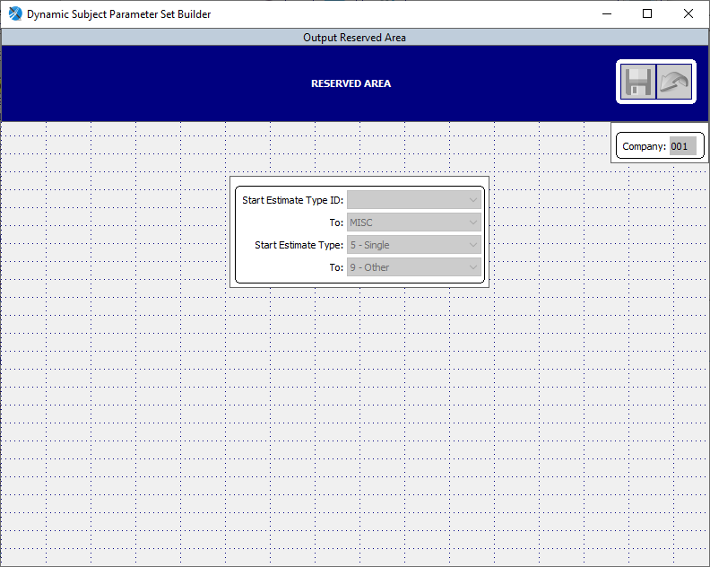
* Parameter Set Layout – adjust the Parameter Sets in a presentable format.
* 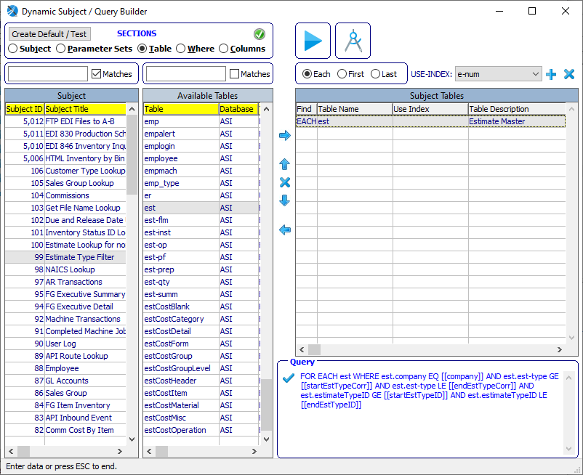
* Subject Table – select the “est” table.
* 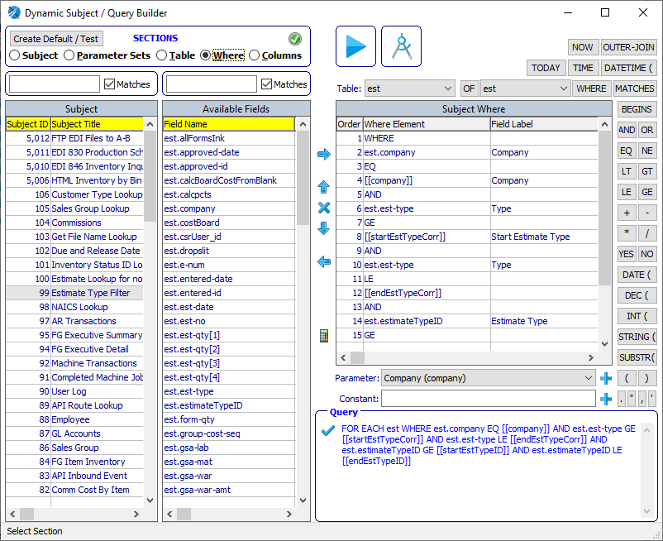
* 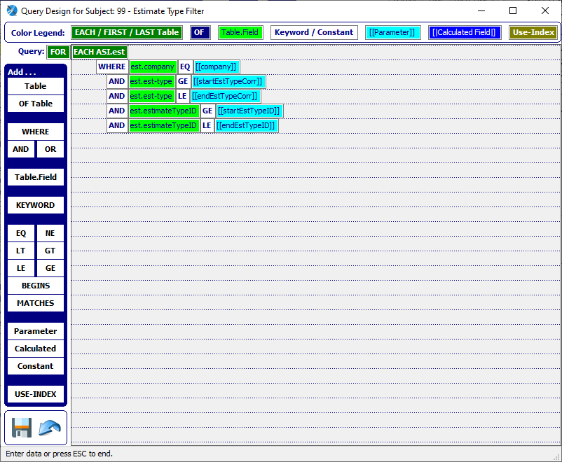
* Subject Where – using either of the above methods, create the Query WHERE PHRASE, WHERE est.company EQ [[company]] AND est.est-type GE [[StartEstTypeCorr]] AND est.est-type LE [[EndEstTypeCorr]] AND est.estimateTypeID GE [[StartEstTypeID]] AND est.estimateTypeID LE [[EndEstTypeID]].
* 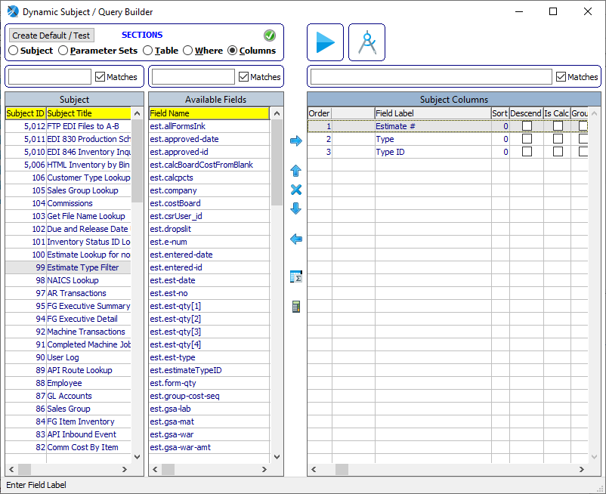
* Subject Columns – select which ever columns allow for the results to reflect the desired results from the subject query, Estimate #, Type and Type ID.
* 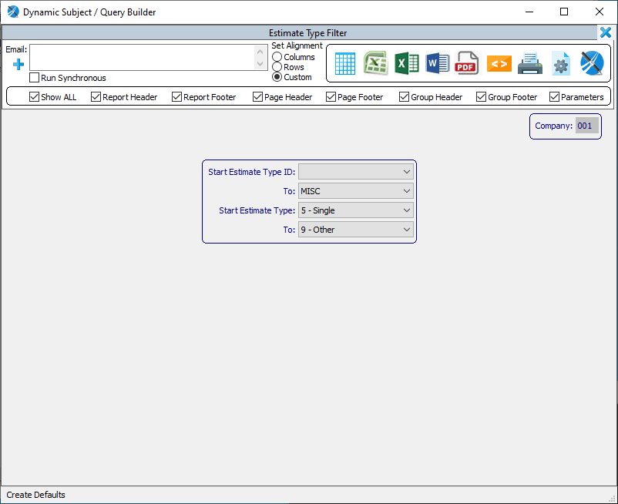
* Test Run – click on the [Create Default / Test] button, set the parameter values as desired and click the [Grid] button to generate the query results.
* 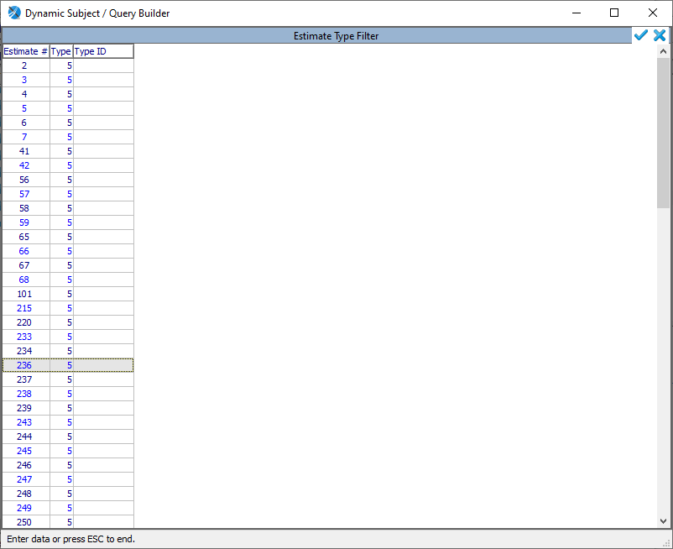
* Run Results – ensure the query results produce are as expected.
* EC Estimate Box Corrugated has the targeted browser “cec/b-estq.w” on it’s Page 1. Since this Window container and Smart Browser are outside the NoSweat framework, maual coding is required to associate this browers with the Dynamic Parameter Filter.
* 
* Smart Browser Definitions Section needs the Parameter Filter variables defined.

DEFINE VARIABLE cStartEstTypeID AS CHARACTER NO-UNDO.

DEFINE VARIABLE cEndEstTypeID AS CHARACTER NO-UNDO.

DEFINE VARIABLE iStartEstType AS INTEGER NO-UNDO.

DEFINE VARIABLE iEndEstType AS INTEGER NO-UNDO.

* Smart Browser Main Block in “cec/b-estq.w” add the include {AOA/includes/pDynBrowserParam.i} after the RUN dispatch statement (shown highlighted in Yellow).

&ANALYZE-SUSPEND _UIB-CODE-BLOCK _CUSTOM _MAIN-BLOCK B-table-Win

/* *************************** Main Block *************************** */

{methods/ctrl-a_browser.i}

{sys/inc/f3help.i}

RUN sys/ref/CustList.p (cocode,'EC', YES, lActive).

{sys/inc/chblankcust.i ""EC""}

FIND LAST blast-eb WHERE blast-eb.company = gcompany

AND blast-eb.est-type > 4 NO-LOCK NO-ERROR.

lv-last-est-no = IF AVAIL blast-eb THEN blast-eb.est-no ELSE "".

&SCOPED-DEFINE cellColumnDat cecb-estq

{methods/browsers/setCellColumns.i}

SESSION:DATA-ENTRY-RETURN = YES.

&IF DEFINED(UIB_IS_RUNNING) <> 0 &THEN

RUN dispatch IN THIS-PROCEDURE ('initialize':U).

&ENDIF

{AOA/includes/pDynBrowserParam.i}

{methods/winReSize.i}

/* _UIB-CODE-BLOCK-END */

&ANALYZE-RESUME

* Procedure local-initialize .add the highlighted in yellow code. Note this is where the Subject Alt ID value of “cec/b-estq” is referenced in the call to RUN pDynBrowserParam as an INPUT PARAMETER. The needed Parameter Filter Values are retrieved here as shown below.

&ANALYZE-SUSPEND _UIB-CODE-BLOCK _PROCEDURE local-initialize B-table-Win

PROCEDURE local-initialize :

/*------------------------------------------------------------------------------

Purpose: Override standard ADM method

Notes:

------------------------------------------------------------------------------*/

/* Code placed here will execute PRIOR to standard behavior. */

RUN pDynBrowserParam ("cec/b-estq").

IF AVAILABLE dynParamValue THEN

ASSIGN

cStartEstTypeID = fGetDynParamValue ("StartEstTypeID")

cEndEstTypeID = fGetDynParamValue ("EndEstTypeID")

iStartEstType = INTEGER(fGetDynParamValue ("StartEstTypeCorr"))

iEndEstType = INTEGER(fGetDynParamValue ("EndEstTypeCorr"))

.

ELSE

ASSIGN

cStartEstTypeID = CHR(32)

cEndEstTypeID = CHR(254)

iStartEstType = 5

iEndEstType = 9

.

/* Dispatch standard ADM method. */

RUN dispatch IN THIS-PROCEDURE ( INPUT 'initialize':U ) .

/* Code placed here will execute AFTER standard behavior. */

RUN setCellColumns.

…

* Smart Browser Query needs to be adjusted to utilize the Parameter Filter variables as follows (note in this module, there are several places these variables are needed and should be added accordingly).

&SCOPED-DEFINE for-est ~

EACH ASI.est WHERE ~{&KEY-PHRASE} ~

AND est.company EQ g_company ~

AND est.est-no EQ eb.est-no ~

AND ASI.est.est-type GE iStartEstType ~

AND ASI.est.est-type LE iEndEstType ~

AND ASI.est.estimateTypeID GE cStartEstTypeID ~

AND ASI.est.estimateTypeID LE cEndEstTypeID ~

AND ((est.est-type EQ 5 AND tb_single) OR ~

(est.est-type EQ 6 AND tb_set) OR ~

(est.est-type GT 6 AND tb_tancom))

* EB1 Machine File has the targeted browser “browser/mach.w” on it’s Page 1. This module is within the NoSweat framework and requires very minimal code additions to attach the Dynamic Parameter Filter.
* 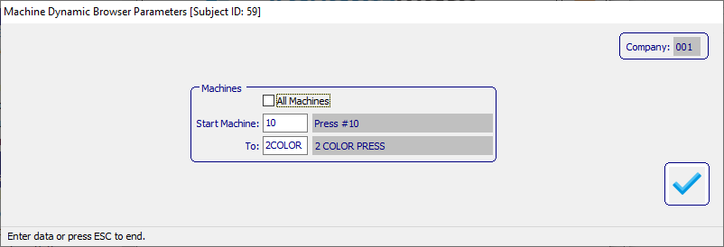
* 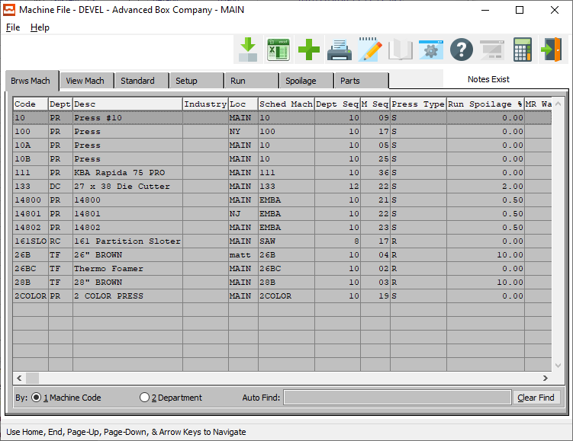
* Navigate to ND2 Dynamic Subject Builder, select Subject ID 59 and set it’s Subject Alt ID to “mach”.
* Add the Parameter Filter variables to the Definitions Section

DEFINE VARIABLE cStartMachine AS CHARACTER NO-UNDO.

DEFINE VARIABLE cEndMachine AS CHARACTER NO-UNDO.

* 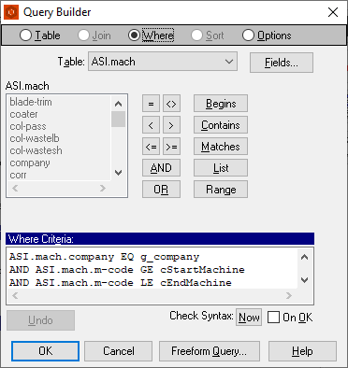
* Within the Progress App Builder, navigate to the Query Builder of the Browser object and add the Parameter Filter variables to the Where Criteria phrase.
* Open the include {custom/brwsinit.i} and add the value from the Scoped-Define FIRST-TABLE-IN-QUERY-{&BROWSE-NAME} … in this case it’s table “mach” (as highlighted in yellow).

account ~

ar-invl ~

bank ~

buyer ~

costtype ~

cust ~

custype ~

carrier ~

fgcat ~

item ~

itemfg ~

loc ~

mach ~

matprep ~

prep ~

procat ~

prod ~

prodl ~

routing ~

sman ~

stax ~

std-code ~

style ~

terms ~

terr ~

vend ~

ventype ~

fg-rctd ~

r-cashl ~

p-payl ~

e-boll ~

oldto ~

ust-markup ~

hipto ~

mpalert

* Create a new include (if it doesn’t already exist) {methods/browsers/initial/mach.i} and add the following code to extract the Parameter Filter Values into the Parameter Filter Variables.

IF AVAILABLE dynParamValue THEN

ASSIGN

cStartMachine = fGetDynParamValue ("startMachine")

cEndMachine = fGetDynParamValue ("endMachine")

.

ELSE

ASSIGN

cStartMachine = CHR(32)

cEndMachine = CHR(254)

.

* Dynamic Parameter Filters assigned to selected User(s). is done when an Admin User invokes a Dynamic Parameter Filter and the Users icon is present.
* 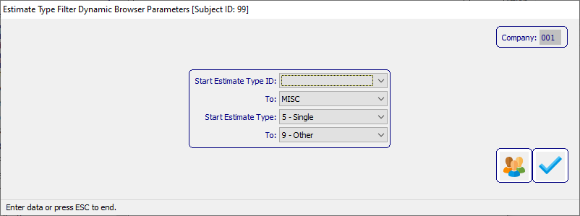
* 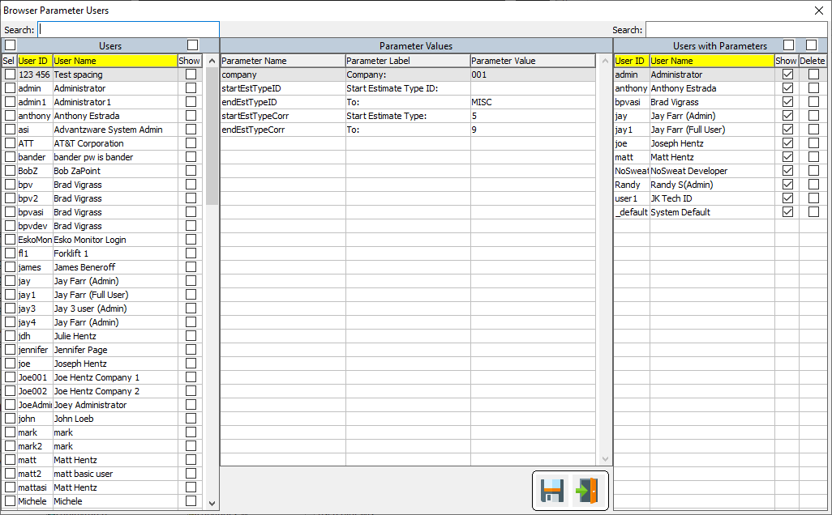
* Browser Parameter Users allows an Admin User to select Users and unselect Users from the Dynamic Parameter Filter. This module can set whether a Parameter Filter is visible to the User. This allows the Admin to hard set the Parameter Filter values and prevent the selected User from changing the values.
  + Users [left panel] shows every User within the system. Simply check off one or more Users to assign the Parameter Filter values displayed in the center panel. If the Paremeter Filter is desired to be presented to the User, check off the Show column. Leaving this unchecked will not present the Parameter Filter to the User and uses the Parameter Filter values as set in the center panel. After the desired selections are done, click the SAVE (floppy disc icon). Newly selected Users will now appear in the right panel.
  + Parameter Values [center panel] display the Parameter Filter values are currently selected. To change these values, either EXIT (exit door icon) and change the values and re-click the Users icon, so select a User with Parameters from the right panel to display the values associated with the right panel User.
  + Users with Parameters [right panel] shows all the Users associated with this Parameter Filter. Check/Uncheck the Show column to Show/Hide the Parameter Filter for the selected User. To remove a Parameter Filter from a User, check the Delete column. After all the columns have been checked and/or unchecked, click the SAVE (floppy disc icon) to effect the changes accordingly.